Redux
Module Introduction:
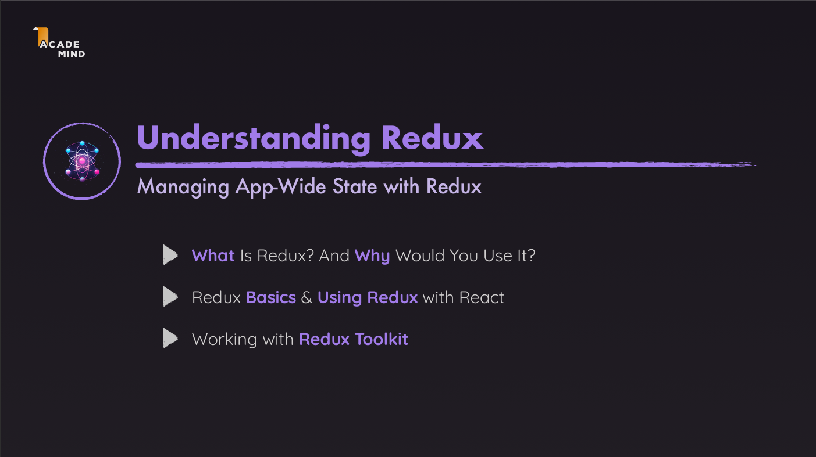

Redux is a JavaScript library used for state management in frontend applications, especially in conjunction with React, although it can also be used with other libraries. Redux aims to solve the complexity of managing states in large applications with many interconnected components.
Why Do We Need Redux?
When building React applications or any applications with reusable components, managing the state (data) between these components can become highly complex. Imagine a large application with many nested components that need to share data. This is where Redux comes in, providing a centralized and simplified way to manage state.
The Core Concept of Redux:
Redux operates on the principle that the global state of your application is stored in a single object called the store. This state can only be updated through actions, which are processed by a function called a reducer. Redux enforces a unidirectional data flow, making it easier to track and understand how data moves through the application.

Three Core Principles of Redux:
- Single Source of Truth:
  - In Redux, the entire state of the application is stored in a single object tree inside the store. This ensures there is one place to look when trying to understand the current state of the app.
- State is Read-Only:
  - The only way to change the state is by dispatching an action that describes the changes that should occur. This keeps the data flow traceable and prevents direct state mutations.
- Changes are Made with Pure Functions:
  - In Redux, reducers are pure functions that receive the current state and an action, and return the new state based on the action. Pure functions ensure that the output is always predictable based on the input, making the state changes reliable and easy to follow.

Key Components of Redux:
- Store: The centralized location that holds the entire state of the application.
- Actions: Plain objects that describe what should be done to update the state, containing a type and any necessary data.
- Reducers: Pure functions that take the current state and an action, then return the updated state based on the action.

Another Look At State In React Apps:
1. Local State:
- Definition: Local state refers to the state that belongs to a single component. It is confined to that component and doesn't affect other components in the app.
- Example:
  - Listening to user input on a form field.
  - Toggling the visibility of a “show more details” section within a single component.
- How to manage it:
  - Managed using useState() or useReducer() hooks within the component.
2. Cross-Component State:
- Definition: Cross-component state is state that affects multiple components in the app. It may originate in one component but needs to be passed and shared between other components.
- Example:
  - A modal's open/closed state that needs to be controlled from different components.
- How to manage it:
  - Cross-component state can still be managed using useState() or useReducer() within the component that holds the state.
  - However, in order to share this state with other components, you will need to use prop drilling, which involves passing the state as props down through the component tree.
3. App-Wide State:
- Definition: App-wide state refers to global state that affects the entire application. This type of state needs to be accessed and shared across many different components and potentially at any depth of the component tree.
- Example:
  - User authentication status that affects access to various parts of the app.
  - A theme (light/dark) setting that needs to be applied across multiple sections of the UI.
- How to manage it:
  - You can use prop drilling to pass the app-wide state to the components that need it. However, this becomes inefficient in large applications.
  - Better alternatives:
    - React Context: Allows you to share state globally without prop drilling by providing a context that any component can consume.
    - Redux: A state management library that centralizes the app-wide state in a store, allowing any component to access or update the state without prop drilling.
Summary:
- Local State: Confined to a single component, managed with useState() or useReducer().
- Cross-Component State: Affects multiple components, shared via prop drilling.
- App-Wide State: Affects the entire application, shared via prop drilling, React Context, or Redux.
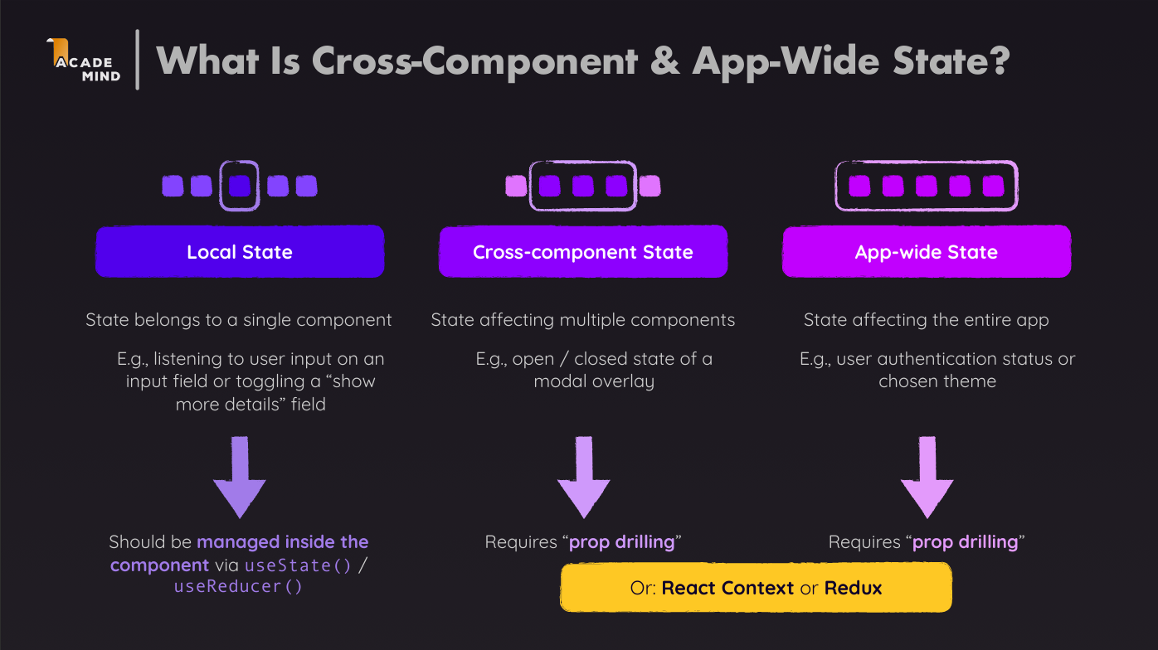

React Context for Managing Multi-Component State
React Context is a powerful feature in React that helps manage state across multiple components without having to rely on prop drilling. Prop drilling refers to the process of passing state or functions down through multiple layers of components, which can become cumbersome and difficult to manage as an application grows.
When to Use React Context:
React Context is ideal for multi-component state or app-wide state, where multiple components need to access or update shared data. Instead of passing props through every component manually, Context provides a centralized way to share state between deeply nested components.
How React Context Works:
- Create a Context:
  - A context is created using React.createContext(). This context holds the shared state and makes it accessible to any component that needs it.
const MyContext = React.createContext();
- Provide the Context:
  - To share the state, a Context Provider is used. This provider wraps the component tree where the state needs to be accessible and passes the shared data.
const MyProvider = ({ children }) => {
const [state, setState] = useState(initialValue);
return (
<MyContext.Provider value={{ state, setState }}>
{children}
</MyContext.Provider>
);
};

- Consume the Context:
  - Any component that needs access to the shared state can use the Context Consumer or the useContext() hook.

const MyComponent = () => {
const { state, setState } = useContext(MyContext);
return <div>{state.someValue}</div>;
};

Advantages of Using React Context:
- Avoid Prop Drilling: It eliminates the need to pass props manually through every intermediate component.
- Centralized State: Makes it easy to share and manage state across deeply nested or sibling components.
- Improved Code Structure: By centralizing shared data, your component hierarchy remains cleaner and more manageable.
When Not to Use Context:
- Frequent Updates: React Context is not optimized for high-frequency updates. For cases where state changes rapidly (e.g., complex forms, animations), using Redux or local state (useState()/useReducer()) might be better.
- Simple State Management: For simple state management that is only relevant to a few components, Context might be overkill. It’s better to stick with prop drilling or local state management.
Summary:
- React Context helps in managing multi-component and app-wide state without prop drilling.
- It is ideal for scenarios where state needs to be shared across multiple deeply nested or sibling components.
- It provides a clean and efficient way to centralize and distribute state across your application.
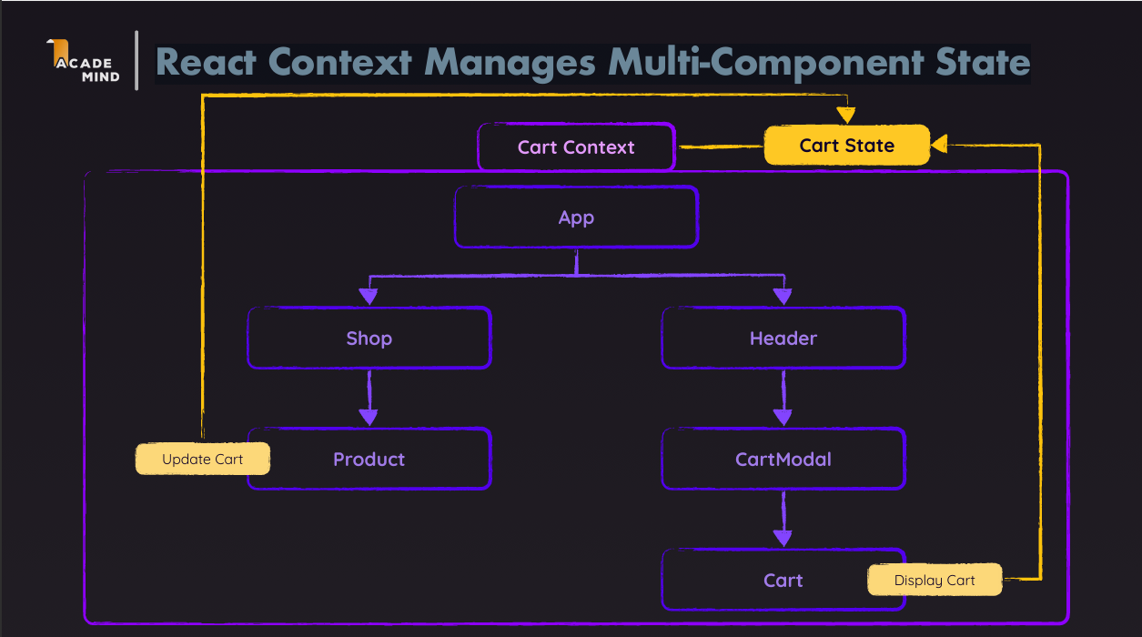

Redux vs React Context:
- Redux:
  - Best for large, complex apps.
  - Stores all app data in one place (central store).
  - Good for handling lots of data and state changes.
  - More setup and learning required.
- React Context:
  - Best for small or simple apps.
  - Shares data between components without passing props (prop drilling).
  - Great for simple, app-wide state like themes or user info.
  - Easier to use and set up.
Key Difference:
- Redux: For big apps with a lot of data and frequent changes.
- React Context: For simpler apps with fewer components needing shared state.
React Context Has Some Potential Disadvantages
- Complex Setup & Management:
  - In more complex apps, using React Context can result in deeply nested or "fat" Context Provider components. This makes it harder to manage and maintain the structure, especially as the app grows.
  - Best Practice:
    - Keep your contexts focused on specific pieces of data (e.g., separate contexts for theme, authentication, etc.) to avoid creating a massive provider tree. Also, consider using Redux if your state management becomes too intricate.
- Performance Issues:
  - React Context is not optimized for handling high-frequency state updates or managing large amounts of data. Frequent re-renders triggered by Context updates can impact app performance.
  - Best Practice:
    - Use React Context sparingly for static or infrequent updates (e.g., themes, user preferences). For more dynamic, frequently changing data, consider Redux, which is optimized for large-scale state management with better performance control.

Best Approach:
- Use React Context for simple or infrequent state-sharing (e.g., themes, authentication).
- Use Redux for large, complex apps that require frequent updates or performance optimizations.
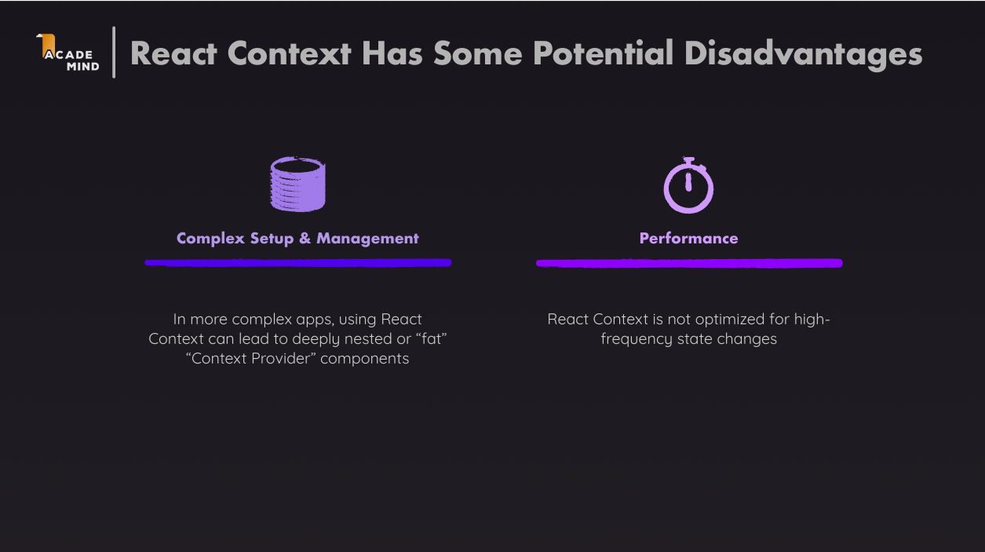
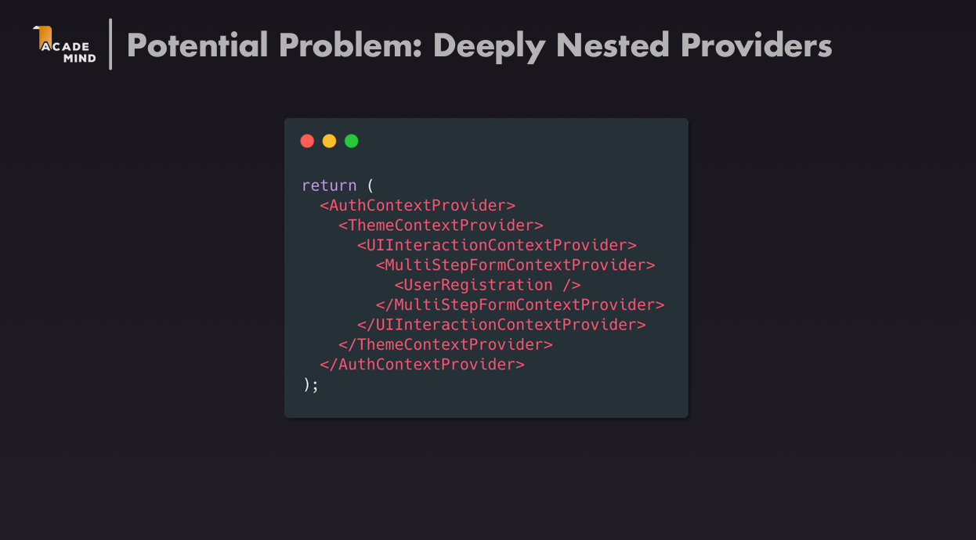
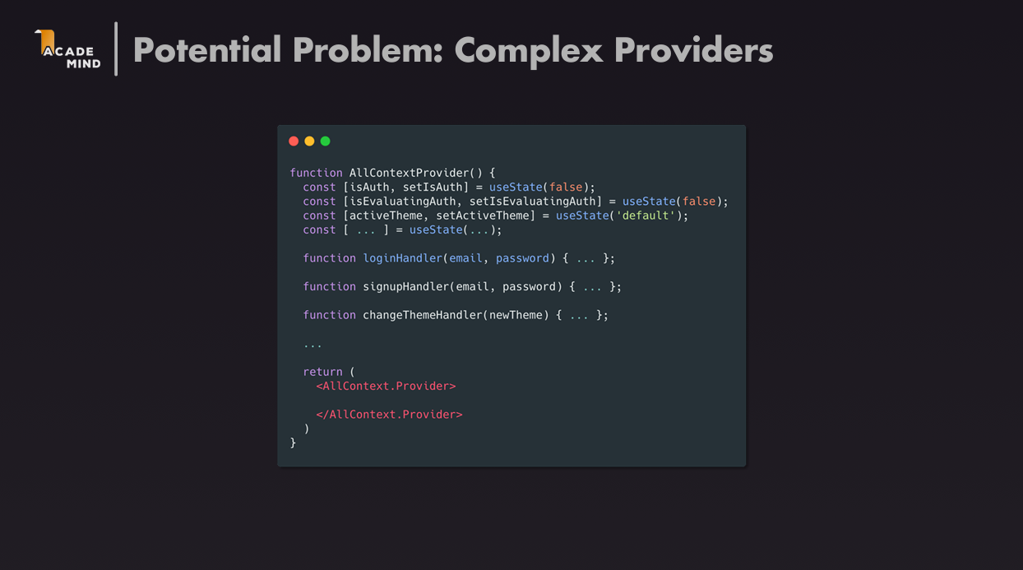
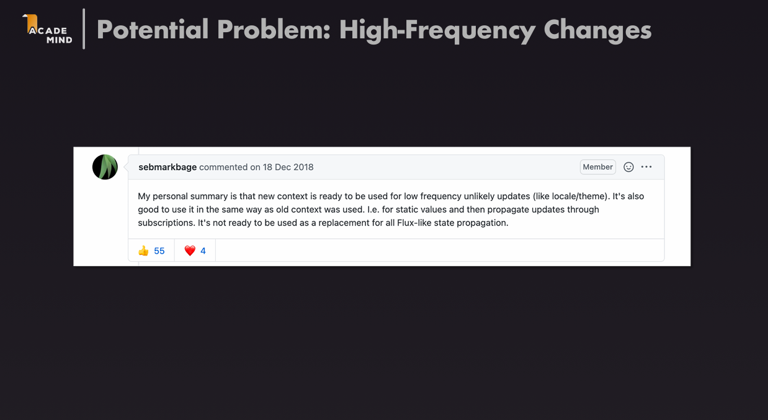

How Redux Works:

